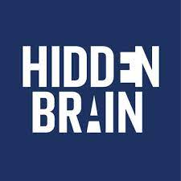
https://www.npr.org/series/423302056/hidden-brain

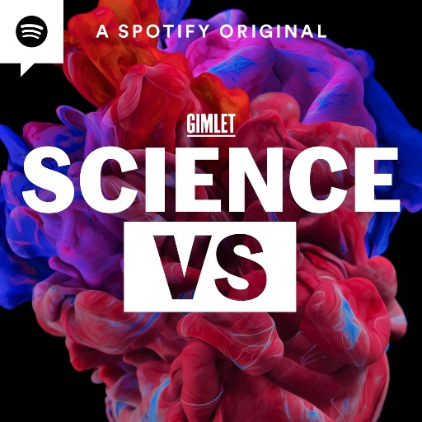
https://gimletmedia.com/shows/science-vs

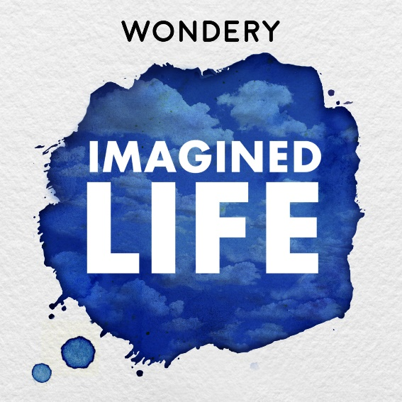
wondery.com/shows/imagined-life/

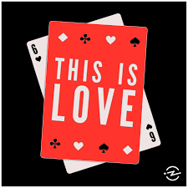
https://thisislovepodcast.com/episodes

https://www.iheart.com/podcast/1119-fake-doctors-real-friends-60367049/

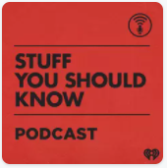
https://www.iheart.com/podcast/105-stuff-you-should-know-26940277/

https://wondery.com/shows/american-history-tellers/

https://www.thisamericanlife.org/

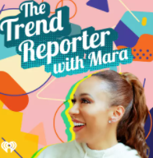
https://www.iheart.com/podcast/269-trend-reporter-30542615/

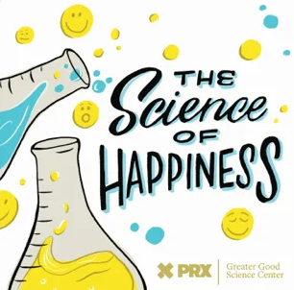
https://podcasts.apple.com/us/podcast/the-science-of-happiness/id1340505607?id=1340505607

https://audioboom.com/channel/football-in-europe-podcasts

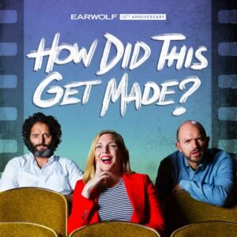
http://www.earwolf.com/show/how-did-this-get-made/

http://bedside-rounds.org/

https://play.acast.com/s/secondopinion

https://www.csis.org/podcasts/truth-matter

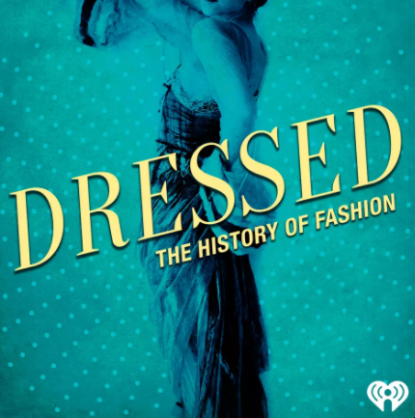
https://www.iheart.com/podcast/105-dressed-the-history-of-fas-29000690/

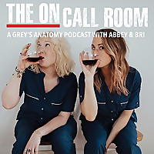
https://www.feedspot.com/infiniterss.php?_src=feed_title&followfeedid=5184780&q=site:https%3A%2F%2Ffeeds.soundcloud.com%2Fusers%2Fsoundcloud%3Ausers%3A298179914%2Fsounds.rss

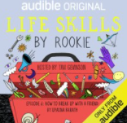
https://soundcloud.com/search?q=life%20skills%20by%20rookie

